A THEORETICALLY-SUFFICIENT AND COMPUTATIONALLY-PRACTICAL TECHNIQUE FOR DETERMINISTIC FREQUENCY SERIATION

Carl P. Lipo1, Mark E. Madsen2, Timothy D. Hunt3 and Robert C. Dunnell4

October 16, 2014

1Department of Anthropology and IIRMES, California State University Long Beach, 1250 Bellflower Blvd., Long Beach, CA 90840, USA, [clipo@csulb.edu](mailto:clipo@csulb.edu), http://lipolab.org

2Department of Anthropology, Box 353100, University of Washington, Seattle, WA 98195-3100, http://madsenlab.org

3Society for the Advancement of Scientific Archaeology (SASA), 819 N 49th St. #413, Seattle, WA, [tim@pre-history.org](mailto:tim@pre-history.org), http://pre-history.org

4Mississippi State University, Department of Anthropology and Middle Eastern Cultures, P.O. Box AR, Mississippi State University, MS 39762

ABSTRACT

While seriation played a key role in the formation of archaeology as a discipline, its utility for exploring issues of contemporary interest beyond chronology has been limited. This limitation is due in part to a lack of a quantitative means for generating deterministic seriation solutions. Brute force methods are simply impossible due to the numbers of possible combinations that need to be explored, a number that easily outstrips all currently conceivable computing processing abilities. Similarity-based measures offer an alternative but rely on generalizations to order assemblages. This generalization eliminates some of the fundamental features of for the premise of the seriation method. Recently, frequency seriation has been reconceived as a general method for studying the structure of cultural transmission in populations through time and across space. This evolution-based framework renews the demand for a fully quantitative technique that is also able to computationally able to produce results under varying configurations. Here, we explore a computer-based algorithm for constructing frequency seriations that uses an iterative design to dramatically restrict the search for potential valid. This technique does not solve all the problems of seriation but begins to moves towards a resolution of a long-standing problem in archaeology while opening up new avenues of research into the study of cultural relatedness.

Keywords: seriation, algorithms, cultural transmission, culture history

As a means of arranging descriptions of artifacts to build chronology, seriation has a played an integral part in the emergence of archaeology as a coherent discipline (Lyman et al 1997). Developed as a chronological method almost 100 years ago, seriation has enabled culture historians to construct regional chronologies and was paramount in generating much our understanding of prehistory throughout the New World (e.g., Beals 1945; Bluhm 1951; Evans 1955; Ford 1949; Kidder 1917; Mayer-Oakes 1955; Meggers 1957; Phillips et al. 1951; Rouse 1939; Smith 1950). Yet, while it remains almost solitary as an explicitly archaeological method, seriation has largely been ignored for the past 40 years due to its association with chronology and the mistaken belief that modern dating techniques have replaced it. Beyond the popular misunderstanding that remains prevalent among many that seriation is simply a “dating technique” that is useful only when radiocarbon dating is impossible (e.g., Wikipedia 2013), the method has never been fully quantitatively derived.

Recently, seriation has regained attention due to the demonstration that the method can be theoretically explained with an evolutionary framework. While Dunnell (1980) hinted at this possibility, the work of Neiman (1995) firmly established an explanatory basis within cultural transmission models for the unimodal distributions that form the core of the seriation algorithm. This achievement has led to the reimagining of seriation as a general tool for studying patterns of cultural inheritance within populations through time and across space (e.g., Cochrane 1998; Lipo et al 1997; Lipo 2001; O’Brien and Lyman 2000; Smith and Neiman 2007; Teltser 1995). There remains a clear potential for seriation, therefore, to once again become a primary tool for archaeological analyses as it enables researchers to not only build chronology but to quantitatively track patterns of interaction among past population, define social communities or trace lineages. In this way, seriation could serve in the establishment of a fully evolution-based discipline.

Despite this potential, the development of seriation as a systematic tool in archaeology remains incomplete. Brute force options are unavailable except for the most trivial cases. Sorting through all possible orderings for a set of assemblages quickly triggers a combinatorial explosion that makes brute force approaches impossible even with modern computing power. Existing quantitative approaches construct orders on the basis of similarity scores, an approach that guarantees a solution but reduces the information that is available in violations of the underlying model. Techniques such as correspondence ameliorate this issue to some degree but at the risk of equifinality. One is guaranteed to find a solution, but the order produced reflects sources of variability beyond time including the effects of sample size, biased transmission processes and space. While techniques such as correspondence analysis offer a relative suggestion about the potential for non-temporal factors, statistical solutions are fundamentally generalizations about temporal relations with limited ability to explain the relations about any specific set of assemblages. While one may know that the overall order is chronological, whether some subset of assemblages is explained as the result of chronology, their layout in space, a function of differences in the relative degree of interaction – or some combination of these factors – is not clear.

Here, we introduce the basis of a new quantitative seriation algorithm that solves the computational barrier while also being based within the logical structure of the method. The algorithm succeeds by iteratively constructing seriation solutions and using successful solutions with small numbers of assemblages as the basis for creating larger ones. The declaration of a continuity parameter that specifies the maximum expected difference in class frequencies allows for the reduction of sub-solution and enables even large number of assemblages to be seriated when solutions exist. The proposed algorithm produces all valid seriation solutions, not just the largest. By aggregating multiple sets of valid solutions, orderings that incorporate space and time are possible, moving seriation beyond simple ordinal “dating” of assemblages and allowing its use in measuring relatedness and cultural transmission at fine scales. We demonstrate how this ability provides a quantitative means of documenting interaction patterns among past communities. Suitably extended, seriation has the potential to inspire new innovative approaches to the archaeological record as much as it did in the 1920s as a critical tool for building chronology.

HISTORY OF THE SERIATION METHOD

While not in common usage, seriate and seriation are perfectly good English words that refer to arranging or occurring in one or more series (Stein 1973:1303). As an English word, however, the term describes the method rather than defines it. Consequently, the origins of the method are a bit opaque since name was applied after the point of its initial configuration. Identifying its history, therefore, requires tracing the components involved in seriation that emerge over time and under which contemporary seriation now exists.

Sir Flinders Petrie (1899) is generally credited with inventing seriation. Working with predynastic Egyptian materials, Petrie used ceramics found in graves to develop a chronology. Petrie’s break with archaeological tradition was to treat each grave lot as a sample of a continuous sequence of changing forms instead of as an exemplar of a period or stage. Since the history of Egyptian ceramics must have followed some particular course and thus presented an unique sequence of ceramic type replacements, the *combinations* of ceramic types found in grave lots allowed him to reconstruct both the history of ceramics and arrange the grave lots in chronological order. As in all seriation, the product was just an order; one had to determine independently (usually through superposition) which end of the order was most recent.

Alfred L. Kroeber (1916) is credited with stimulating the American development. Kroeber did not cite Petrie’s work and likely was developed independently. The form and context of Kroeber’s proposal are dramatically different from Petrie’s and points strongly for an independent origin. Indeed, even in his seminal “Zuni Potsherds” (1916) paper Kroeber describes how the idea of extracting chronology from type composition occurred to him as he observed variability in pottery decoration among southwestern pueblo deposits. The primitive seriation proposed by Kroeber was quickly amended by Leslie Spier, Alfred V. Kidder and Nels C. Nelson all of whom were conducting stratigraphic excavations in the American Southwest (Kidder 1917; Kroeber1916; Nelson 1916; Spier 1917). This group of researchers all noticed that when ceramics were described in a particular way -- called “stylistic” by Kidder -- the temporal distribution of the types took the form of “normal curves.” Coupled with Kroeber’s initial insight, it was apparent that a series of assemblages collected from the surface or otherwise undated could be arranged in chronological order by rearranging them so that all type distributions approximated “normal curves” simultaneously.

As powerful as seriation proved to be, these early formulations were entirely intuitive and based on the generalization that the greater the degree of temporal differences represented in pottery assemblages the greater the differences the frequencies of the decorate types would be. The shape of the curves that led to the ability to order assemblages were not justified and even the terms used were ad hoc: the distributions were not “normal” in a statistical sense. Since knowledge of rates of change was impossible, all that one could say about the characteristic distributions were that they were unimodal in that they had a single peak frequency and decreased in value away from the peak in both directions; monotonic in modern terminology. Furthermore, there was little interest in figuring out why the characteristic distributions occurred. It was enough that they did and could be used to order assemblages. Rationalization was limited to rephrasing the frequency observations as “popularity;” an answer to the question why did stylistic types display “normal distributions” was that styles simply increased in popularity until they reached a peak and then declined. Such statements are, of course, just descriptions of the observed frequencies. Seriation thus was based on an empirical generalization about the distribution of stylistic classes through time.

Almost all of the early work involved frequencies of stylistic (historical) pottery classes used as attributes of assemblages, the assemblages being groups of artifacts, usually but not always, pottery. But as Pertie’s work showed, the groups ordered might be objects, i.e., groups of attributes. Descriptions used for assemblages were frequencies of historical classes; those for objects were presence/absence tabulations

By the 1930s, use of the method had spread from the Southwest to include the eastern United States and the Arctic and by the 1940s even Peru and Amazonia had chronologies based on seriation (e.g., Collins 1937; Meggers 1957). James A. Ford played a critical role in many of these disseminations and was the only scholar to take an interest in seriation as a method until recently (O’Brien and Lyman 1998, 1999). Although Kroeber had been aware of potential problems derived from sample size effects, Ford brought these considerations to the fore, albeit in a highly intuitive, unquantitative, and ultimately incorrect way. More importantly, he deduced a series of conditions under which the empirical generalization driving seriation might be expected to hold: (1) assemblages seriated must represent brief intervals of time; (2) assemblages seriated must come from the same cultural tradition; and (3) assemblages seriated must come from the same local area. The meaning of key terms like “brief interval,” “cultural tradition,” and “local area” were left undefined.

Ford, like his predecessor, arrived at the final arrangement by eyeballing trial and error orderings for conformance to the unimodal-distribution model. Entirely a manual process, Ford’s technique requires arranging strips of paper representing assemblages and with type frequencies graphically depicted as bars. One would move the strips around until the pattern of the bars in each type would match “battleship-shaped” curves. For many workers, this crude process was a critical failure of Ford’s technique. In 1951, George Brainerd and Eugene Robinson proposed an entirely new technique for arriving at the order of groups (Brainerd 1951; Robinson 1951). They devised a measure of similarity, since termed the Brainerd and Robinson Index of Agreement or simply the Brainerd and Robinson Coefficient, with which pairs of assemblages could be compared in terms of type composition. Thus described, they noted that in correct solutions, the most similar assemblages were adjacent to one another; since this order was unique, groups could be chronologically ordered simply by arranging them so that the most similar units were adjacent. Brainerd and Robinson did this by rearranging rows and columns in a square matrix (each group is compared with every other group) of similarity coefficients; in a perfect solution, the magnitude of the similarity coefficients would decrease uniformly (monotonically) away from the axis of identity (the groups compared with themselves). Cowgill (1972) developed a similarity-based approach for occurrence descriptions paralleling the techniques developed by Brainerd and Robinson for frequency descriptions.

Thus, two kinds of seriation approaches emerged. Like Ford, one could insist on an exact match with the unimodal model before regarding an order as chronological, a deterministic solution. Alternatively one could accept the “best fit” to the unimodal model as chronological, a probabilistic solution. Thus, with two kinds of description (frequency/occurrence), two approaches to ordering (identity/similarity), and two possible solutions (deterministic/probabilistic), there are eight different families of seriation techniques available to archaeologists (Dunnell 1971).

Since Brainerd and Robinson, much writing has focused on probabilistic approaches and researchers have brought increasingly sophisticated statistical approaches to bear on seriation (e.g., Atkins 1998; Bordaz and Bordaz 1970; Brower 1985; Buck 2002; Djindjian 1984; Gargano and Edelson 1996; Gargano and Lurie 2006; Halekoh 1999,2004; Hubert 2011; Kendall 1970; Liiv 2010; Wilcock 1995; Wilkinson 1971). These statistical methods generally seek to find “best” solution by reduction of data complexity to a few dimensions. They will find a solution even when a single solution is not possible and most will measuring the departure from a perfect solution by calculating stress or by examining variability along additional dimensions. As a whole, these techniques treat seriation is an empirical generalization about the way “data change” through time rather than a set of theoretical rules used for explanation. Variability in the frequencies of classes beyond the generalization is treated as noise rather than information about violations to the model and much of the utility of deterministic solutions that can be created by hand ordering is lost. Consequently, most of these quantitative approaches remain in the programmatic literature. Most practical work continues to be done pretty much as Ford did it in the 1950s, hand creating orders using graphical representations of relative frequencies in order to establish deterministic solutions.

It is not accidental that practical approaches to creating solutions have remained largely hand-built despite the availability of computer processing tools. Seriation, whether employing class frequencies or simple occurrence information to order assemblages, yields solutions that are permutations of the set of assemblages. These permutations are vast in numbers. Seriation solutions have often been related to the “traveling salesman problem” (TSP) in which one is given a list of cities and their pairwise distances, and tasked to find the shortest possible route that visits each city exactly once and returns to the origin city (Kadane 1971; Laporte 1978; Wilkinson 1971). If one tries to solve the TSP by examining all possible routes, it quickly becomes impossible as the number of solutions increases exponentially with the number of cities in the list.

In seriation, the situation is even worse because the number grows as the factorial of N. For any *N* assemblages, Equation 1 calculates the number of possible orders (*S*) of length *N*.

**Equation 1: $S=\frac{N!}{2}$**

Due to the factorial relationship, even with a modest number of assemblages, the set of possible solutions is immense. For example, deterministically examining all solutions for a set of 20 assemblages requires searching through 1,216,450,000,000,000,000 combinations. With a reasonably powerful desktop computer (such as a quad core processor machine simultaneously evaluating 4 solutions at a rate of one every 5ms for each processor) the task of sorting through the possible combinations would require 48,000,000 years (Madsen and Lipo 2013), and even with access to a research-grade computing cluster or supercomputer, brute force approaches are impossible.

In fact, the situation is much worse than these daunting numbers. In any set of assemblages, the maximum solution may not include all of the assemblages. Instead, there may be any number (*Sk*) of shorter valid solutions with possible lengths of *Nk* where *Nk < N.* This means that the possible search space to evaluate all solutions includes the all combinations of N plus all the possible subsets until the smallest possible seriation when there are just combinations of three assemblages.

To calculate all of the possible solutions including the possible subsets of N assemblages, we need to consider all of the ways that N objects can be partitioned into M non-empty subsets (or solution groups). These combinations are defined as Stirling numbers of the second kind, can be calculated by the recursion equation as shown in Equation 2.

**Equation 2**:



Using this recursion equation, we can then calculate the total number of subsets of N assemblages, over all subsets with a size of *i* with Equation 3.

**Equation 3:**



Finally, Equation 4 produces the total number of possible solutions for N assemblages, given solutions of any size, with the total number of possible orderings within those solutions.

**Equation 4:**



Based on this relation between assemblages and numbers of solution, the numbers the possible combinations quickly gets impossibly large. For example, considering all of the solutions possible in a set of 20 assemblage set could require 8,121,916 years of computer processing, a calculation which is converted to a slightly less unreasonable 8100 years if we have access to 1000 simultaneous cores that can do one evaluation every tenth of a millisecond. Even with this relatively small set of assemblages and the capabilities of supercomputer, there is no way of exhaustively searching the combination space for valid seriation solutions within a lifespan.

It is useful to note statistical approaches are in a sense a response to the notion that seriation is inherently a problem of evaluating all possible combinations, and thus computationally difficult or impossible. From this perspective, a similarity approach attempt to avoid the problem by representing seriation as an exercise as finding extrema (minima/maxima) of a matrix of distances or similarities.  The approximate solutions are a way of coming up with an answer when actually doing the work of the combinational evaluation is not possible. This strategy is equivalent many of problems that are considered by mathematicians as either “NP-hard” or “NP-complete”. Interestingly, while statistical approaches could produce approximate answers, they do so by throwing away unique frequency pattern information. This frequency information, in fact, could be used to help winnow possible solutions.

In a theoretical sense, we contend that model-driven seriation is not necessarily a combinatorial nightmare -- that the combinatorial issue is partially a function of having reduced the description of the problem to one that has the same computational complexity as other "intractable" problem, such as the "traveling salesman" problem or finding Hamiltonian paths in a graph[1]. By using concepts closely linked to cultural transmission theory we can achieve a description that has better performance properties, though any such method will still be computationally expensive.

Deterministic solutions have advantages over statistical approaches since they make use of all of the type frequency information for each assemblage to build orders. Using detailed comparison of all frequencies it is possible to winnow out invalid solutions and greatly reduce the potential solution space. However, currently only hand-built approaches have been the only feasible way of creating deterministic seriation solutions. Hand-built solutions have the advantage of a general pattern recognition strategy that is inherent in our cognition. While unquantifiable and imperfect, researchers have had to accept the problem that hand-built solutions are effectively a “best guess” or suffer from the limitations of probabilistic techniques. Ultimately, however, neither choice is satisfactory since the strength of the seriation as a method rests on deterministically finding all the solutions that match the requirements of continuity and unimodality. Since we explain variability in frequencies as a function of transmission through time and space, finding the points at which assemblages cannot be seriated is as important as finding those that do (Lipo and Eerkens 2008; Lipo et al. 1997). “Approximate” solutions built through generalizations rather than deterministic quantitative algorithm sharply limits the degree to which the approach can be used to explore different contributions that distinct conceptual components inherent in the theoretical framework of the method, only one of which is time.

# Explaining the seriation method

To understand how to build a systematic means of building an algorithm that is true to the seriation method, one must look in detail at its requirements. In his 1971 paper, Dunnell evaluated Ford’s criteria. Ford’s conditions 1 and 2 were found to be sound and conditions that groups to be seriated (objects or assemblages of objects) had to meet for the generalization warranting the method to apply. Groups did not have to be of short duration (time between the addition of the first and last element to the group) in some absolute sense as Ford supposed, but group duration did have to be comparable among the included cases. Groups did have to belong to the same tradition (ancestor-descendent relationships). While there was no way to assess whether these conditions were met *a priori* by a given set of assemblages, Dunnell showed using deterministic-identity approaches, seriation could not be made to yield incorrect answers on these grounds, thus securing the chronological warrant for arrangements derived by those techniques. The other techniques are not robust in this regard and the orders arrived by those means may or may not be chronological.

The “local area” criterion proved to be another matter. Dunnell (1971) showed that this condition did not apply to the groups to be seriated as Ford had assumed. Rather it was a deficiency in the warranting generalization; the method was under determined. The generalization only spoke to temporal distributions of types, not their spatial distributions. As Ford intuitively appreciated and others showed empirically in the 1960s, frequencies of types varied in space and that variation could be mistaken for difference in age. Ford’s solution was to limit the amount of space in a seriation, but this was a jerry-rigged solution. To get rid of spatial variations would limit a seriation to a simple point in space; it would be the same thing as superposition. Using the different properties of space and time, Dunnell showed that spatial variation could be eliminated by multiple seriations of the same events using different materials (e.g., pottery types, point types, grave types, etc.) and extracting the common order as chronological. Seriation thus became a more complicated and demanding dating method. Archaeological reaction to this was mixed. Many simply abandoned the method relying on other methods like 14C dating wherever possible; others simply ignored the limitations of seriation and continued in the manner of Ford.

A modern resurgence of interest has been simulated by theoretical development. Dunnell (1982) showed that evolutionary theory could explain why the empirical generalizations driving seriation were true to the extent they were and why they failed when they failed. Taking historical classes to represent neutral traits (i.e., traits not under selection because they have no functional impact), the only forces that could act on their temporal and spatial distribution are strictly stochastic (drift). This is what produced both the unique, historically non-repetitive sequence of forms on which the method depended and also accounted for the unimodal distributions. Recently, other workers (Neiman 1995; Teltser 1995) have extended this work considerably. Now that the underlying theory is understood, the liability posed by spatial variation for seriation as an empirical method promises to become a major tool for investigating spatial organization of human communities as well as a dating method (Lipo et al. 1997).

# A Model-Based approach to solving the seriation conundrum: IDSS

The problem remains, however, as to how to turn this theoretical knowledge into a viable quantitative technique that will permit systemic generation of seriation results that can be statistically evaluated and significance determined. Even with a new theoretical understanding of seriation, workers still rely on manual sorting of assemblages to produce orders though the arranging can be done on a computer rather than physical strips of paper (Lipo 2001). Compromise solutions provided by correspondence analysis provide information about deviations from single solutions (Smith and Neiman 2005) but the technique will always produce a single ordered set of assemblages even when no single result is possible. All descriptions of artifacts built from any kind of classes can be sorted statistically but the orders produced are not necessarily seriations as defined by the method. Thus, these statistical methods are not particularly productive since their results are generalizations rather than explanations.

Moving forward requires us to construct a technique that meets the demands of the seriation method, as we now understand it. Such a technique must be able to find all viable deterministic solutions with finite amounts computational processing for even relatively large sets of assemblage (e.g., 50 or 100) and do so repeatedly so that bootstrap statistics can be used to determine significance and the effects of sampling. In the space created by all the possible orderings of assemblages, the vast majority of orders are invalid, as the combinations would violate the conditions of the seriation method due to deviations from unimodality and/or continuity. Thus, the way to avoid the traveling salesman problem inherent in seriation is to devise a meaningful heuristic that can reduce the search space to just the regions that are guaranteed to have solutions.

The technique we propose to accomplish these goals is called the Iterative Deterministic Seriation Solution (IDSS). IDSS iteratively searches for possible seriation solutions with the smallest possible valid orders of assemblages and then using all valid combinations to search for those that are larger. The smallest possible set of assemblages that can be ordered and that can evaluated in terms of the degree to which they meet the demands of the model is three. For sets fewer than three (pairs), it is not possible to reject any combinations. With three assemblages (triples), the only orders that are possible are those in which the frequencies for each of the classes show a steady increase, steady decrease, a middle “peak”, and no change at all. Assemblage orders that have frequencies that decrease then increase can be rejected.

The next step in the procedure is to take the successful triples and see if any of the remaining assemblages can be added to either end to create a set of four assemblages while avoiding violations of the seriation model. Again, only the successful combinations of four are then used to assess the potential combinations of five. This process is then repeated iteratively until either there no assemblages remaining to be linked to the ends of the existing orders or until no larger valid seriation solutions can be found.

The logical basis of this procedure is that all larger solutions consist of, by definition, smaller subsets of valid solutions. Thus, the valid solution set of six assemblages labeled A-B-C-D-E-F also includes valid subsets such as B-C-D and B-C-D-E. So if we start with all valid triple solutions and sequentially check which solutions include valid sets of four assemblages, and so on, we are guaranteed to end up with the largest possible solution. This process vastly trims down the number of possible solutions since once we weed out the invalid combinations at every step; we no longer have to search all the future combinations that begin with that subset.

While this iterative approach reduces the numbers of combinations, the numbers of possibilities to examine still quickly gets large. Following Equation 2, this is due to the fact any large solution of *M* assemblages (a subset of *N,* where *M<N*) also includes the number of further subsets as determined by Equation 2. So while we able to avoid checking combinations that do not meet the criteria of the seriation method, the sheer number of valid solutions contained *within* any large ordered set becomes overwhelming large. While these solutions are considered trivial since the full set includes these orderings, they are potential combinations that must be searched before the overarching seriation is discovered.

Solving this secondary problem requires returning the basis of the seriation method. Recall that Ford’s criterion states for assemblages to be seriated they must come from the same cultural tradition. This means that the differences in frequencies between any two assemblages can be assumed to be a function of differences in the degree of interaction. In an ideal set of assemblages that sample inheritance that is generated within a single cultural tradition one would expect smoothly continuous frequency changes that are going to be the explained by time and/or space. When multiple cultural traditions are combined, the differences in frequencies will be discontinuous since more than one set of processes and thus any order is more likely due to chance than anything else. What this means in practice is that discontinuity in frequencies reflect the potential for more than one cultural tradition or sampling error. Resolution of these options requires additional samples.

Since arbitrary parts of a single large solution put together will also produce discontinuities, we can use the same continuity principle to rule out solutions that we do not need to evaluate. By arbitrarily assigning a threshold of discontinuity measured by the maximum allowable difference between any pair of assemblages within an ordered set, one can rule out most of these trivial solutions. Consequently, as we iteratively search for possible assemblages that can be added to either end of an existing one, we can rule out all of the possibilities that are too dissimilar for consideration. This step allows us to ignore comparisons between assemblages and reduce our search space.

Of course, establishing a continuity threshold requires user input and which means that the search space is partially shaped by the researcher. The analyst must specify the greatest degree of differences in assemblage type frequencies to be considered as related. We implicitly do this when we choose the set of assemblages to include in our seriation, by selecting some assemblages in an area and not others. Taking this step further, we can specify the maximum discontinuity allowable within a set of assemblages that can be considered as directly related to one another. In practice, this means stipulating a maximum frequency differences in any one type or summed for all types. In an ideally generated set of assemblages, the maximal difference between the frequencies of types might be relatively small since good sampling should ensure continuous change in frequencies. The size of the threshold in many cases will be a reflection of the degree to which the assemblages have sampled the set of events that produced the assemblages in the first place. In most cases, the discontinuity threshold can be set higher to tolerate bigger gaps in the frequencies, but at the cost of a greater amount of processing required to search for solutions.

## Initial Implementation

We have implemented IDSS in code written in python. While not optimal in terms of its processing speed, python provides a simple means of converting the conceptual process into a functional algorithm. Figure 1 explains the steps of the code in pseudo code form. Information on downloading and running the program can be found in Appendix 1.

Tests of the IDSS show that ideal data in which an *a priori* solution is known, can be rapidly identified. In Figure 2A, we show a set of 15 unordered assemblages each with 7 types. Figure 2B consists of the largest solution among these 15 assemblages using a standard graphical display. Using a threshold of 0.10 (i.e., the maximum search distance are assemblages that have type frequencies of no more than 0.1 difference), the IDSS algorithm was able to locate the seriation order of these assemblages in just over 1470 seconds. Compared to an estimated 44 years for brute force sorting methods assuming 1 milliseconds sorts per second, this achievement clearly brings frequency seriation sorting to a position in which it can move from intuitive hand-sorting to automated and systematic analysis at least when the solutions include 20 or fewer assemblages. Solutions with larger numbers of assemblages, however, requires narrowly defining the threshold of maximum differences between assemblages or the possible combinations overwhelm our ability to evaluate the potential options. Implementation of massive parallel processing should help ameliorate this effect to some degree. However, there are still limits as to the number of assemblages that can be seriated. The number of assemblages, however, is a common set at least for many archaeological cases conducted within local regions. In particular, many large sets of assemblages break down to much smaller subsets when ordered deterministically and thus can be analyzed quickly.

## Graphical Representation

Figure 2 represents the traditional graphic form for seriations in which the width of the horizontal bars represents the magnitude of the frequencies of types for individual assemblages. The information provided by the bars is not central to the logic of the method but related to the hand construction of seriation where the graphical representation was used directly to create order.

A simpler way of representing the relationships between assemblages is to treat them as graphs. Graphs are a means of representing data structures and can accommodate linear as well as nonlinear relations (e.g., Diestel 1997; Flament 1963; Harary 1969; Wasserman and Faust 1994). Graphs are used frequently in computer science to solve problems such as finding the shortest airplane route between two cities. Graphs are also used to begin to aid in the interpretation of trees and to visualize timelines of interaction (e.g., Morris et al. 2003). Visually, the graphs consist of a collection of vertices and edges, the latter of which connect vertices.

We can create a graph representation of our data by connecting assemblages via edges in the sequence produced by the IDSS algorithm. This simplified output then just informs us about the relations between assemblages without the information regarding the composition of the types. Figure 3 presents the graph representation of the 15-assemblage seriation solution. In addition to being simpler, the graph representation allows us to examine relations where assemblages may be shared in multiple valid solutions. It is not possible to represent overlapping solution in conventional seriation representations but simple with graphs (Cochrane and Lipo 2010; Lipo 2005).

The ability of graphs to reflect complex set of relationships, however, makes interpreting the results more difficult. The strength of seriation is that the result is a linear set of relations where the order reflects some combination of differences in time and space. However, if assemblages are found in more than one solution, additional analytic steps must be taken to reduce the results to something that can serve as a hypothesis about the structure of transmission and the relations between assemblages. As demonstrated in Figure 4, we first create graph that consists of the sum of all of the edges from the individual solutions where the edges are weighted by the summed differences in type frequencies between pairs of assemblages. We then construct a ‘minmax’ solution (*sensu* Lipo 2005) by iteratively adding vertices and edges starting with edges with the lowest weight.

As an example, Figures 5 through 9 represent a case in which a set of assemblages that initially represent a single lineage with a single temporal order branches into two sub-populations, each having valid seriation orders. Such a scenario might happen, for example, if a group of individuals who begin by exchanging information later become two smaller populations that only interact locally, or when single location serves as a center node for two or more relatively separate sub-populations. In this scenario, one would expect at least two different valid seriation orders, one for each ‘branch’ but with a some assemblages included in both. In a traditional representation of this seriation we would be forced to show each solution separately in linear patterns. Using a graph representation, however, we can easily show how the order branches into two different paths. This is done by create a superset graph consisting of both solutions where vertices are connected to more than two edges.

### *Statistical Evaluation*

In generating valid seriations that reflect variability in the archaeological record related to inheritance, we assume that the assemblages are described with stylistic classes (*sensu* Dunnell 1978; Lipo and Madsen 2001). We also assume that the assemblages have been evaluated in term of minimum sample size requirements. Sample sizes must be great enough to ensure a minimum of statistical confidence in the frequencies of classes –otherwise the frequencies may reflect a lack of proper sampling and not the archaeological record. Early culture historians used a fixed number such a 50 to be the minimum size required (e.g., Phillips *et al*. 1951). Better are bootstrap tests that are sensitive to aspects of assemblage richness and diversity (Cochrane 2003; Lipo *et al.* 1997).

Even when minimum sample size requirements are met, the comparisons between any pair of assemblages must be evaluated in terms of statistical reliability. The larger the sample size, the greater the confidence one has that the patterns between the frequencies of classes reflects the archaeological record and not the happenstance configuration of the sample’s description or circumstances. This uncertainty propagates through the entire seriation order: any solution obtain has statistical confidence based on the strength of the pattern between the pairs of assemblages.

If we wish to specify the confidence of our seriation solution, we can construct confidence limits for the frequencies of individual classes. These confidence intervals then serve as the basis for assessing the strength of the pattern of frequencies. In terms of statistical models, a set of proportions from **M** classes is a sample from a multinomial distribution with **M** categories. Calculating confidence intervals for multinomial proportions is remarkably complex and there is not an exact method that is generally recognized. When the number of classes is "large" (i.e., > 10), the Glaz and Sison (1999) method is generally thought to be the best, while **M** < 10, Goodman (1965) is preferred. In our implementation of the IDSS we use a bootstrap means for calculating the values for the bootstrap confidence intervals at a requested significance level for each pair of assemblages. This step consists of creating a large number of new bootstrap assemblages with the same sample size by resampling the original assemblage with replacement. We calculate class frequencies for each of the bootstrapped assemblages. Using the pool of assemblages as the basis for the distribution of frequencies, we then determine the limits of the confidence intervals for the designated level of significance (α).

We use the bootstrap confidence limits when we make comparisons of frequencies between assemblages during the iterative assemblage testing steps. The differences between frequency classes must exceed the limits of the confidence interval in order for the pairs of assemblages to be evaluated having frequencies as “greater than” or “less than” one another. All comparisons in which frequencies values fall within the confidence intervals are scored as “matching.” Since matching frequencies do not violate the assumptions of the frequency seriation model, this process has the effect of creating a greater number of valid solutions. This greater set of solutions thus reflects the statistically valid seriation solutions at a given level of significance. Figures 10-11 provide an example of how bootstrapped confidence intervals can produce different solutions from straight frequency comparisons especially when sample sizes of the assemblages ore differences in frequencies being compared are small.

# Seriation Example from Phillips, Ford and Griffin (1951) and Lipo (2001)

Archaeology conducted in the lower Mississippi Valley provides a useful example of how the concepts behind cultural transmission form the basis for generating explanations, and no better case study exists than the long-term efforts of Phillips and his colleagues (Phillips et al. 1951). Through a series of surface collections and the use of seriation order assemblage, this work provided a remarkably solid chronological framework for the Mississippi River valley and established it as one of the primary foci of American archaeology (Dunnell 1985; Lyman et al. 1997; O’Brien 1996; O’Brien and Dunnell 1998; O’Brien and Lyman 1998).

Using a subset of data from the original Phillips et al. (1951) assemblages and new ceramic collections from seven deposits in northeastern Arkansas, Lipo (2001; Lipo et al 1997) used seriation-based techniques and simulations of cultural transmission to account for patterns of stylistic similarity in varying spatial and temporal configurations among 20 late prehistoric locations. Lipo (2001) demonstrated that stylistic descriptions of these collections provide an excellent case for examining transmission for a number of reasons. First, recollections conducted on a sample of the locations demonstrate that the field techniques used by Phillips and colleagues ensured that assemblages are composed of large, unbiased samples of ceramics with a composition of features that reflect the character of the deposit and not the idiosyncrasies of the procedures by which they were generated. Second, the samples are sufficiently large to provide statistically meaningful class frequencies. Third, class compositions used for ‘types’ are constructed using only stylistic dimensions to avoid patterns due to factors other than cultural transmission. Fourth, culture historical type descriptions were collapsed in some cases in order to ensure that all classes are comparable with one another on the maximum number of sherds of varying sizes. Since they are surface collections, the assemblages varied in terms of their persistence in the plowzone and thus the sherd size. Standardization of the types ensures that the relative difference in frequencies is not dependent on whether a sherd is large enough to recognize a type or whether different collections were described different individuals resulting in non-archaeological variability in type frequencies.

In his analysis, Lipo (2001; Lipo and Eerkens 2008) constructed deterministic seriations for the assemblages using manual graphical technique and found that the no single solution could be obtained using the 20 assemblages. Instead, the set of assemblages had to divided into 8 different spatial groups. These groups reflected the effects of local transmission among communities that overwhelms the effects of interaction over the region. Interestingly, two valid seriation solutions in the “Parkin” area (groups 2 and 3 in Figure 12) overlap with one another in that they both share the assemblage 11-N-1, the Parkin site. Lipo explained this result as the effect of Parkin acting as a central “node” in a network and possibly indicative of emerging social complexity among otherwise functionally redundant settlements.

While Lipo’s result demonstrates the potential for seriation as a means of explaining patterns of cultural transmission, the results and the approach as a whole is limited in practical utility for a number of key reasons. First, the seriation results were created by hand sorting following graphic methods outlined by Ford (1949; Phillips et al. 1951) though with a digital version. Consequently, we have no way of knowing whether the final sets of orders are the largest set or not or whether all possible solutions are represented. Second, while Lipo ensured that the assemblage sizes were adequate for comparisons of richness and diversity, we cannot specify the confidence interval for which this final solution represents. Using an algorithm established by Hunt (Lipo et al. 1997) the graphical representation included error terms for the frequencies to guide sorting, this served as relatively a rough means to ensuring that orders were statistically warranted. Finally, using frequency graphs as the graphical representation of each solution, Lipo demonstrated how seriation orders overlapped or intersected with one another and that this overlap potentially allows one to infer information about prehistoric social structure. The frequency bar graph, however, simply is incapable of representing anything other than linear orders. This limitation limits the degree to which the approach can be systematically applied especially as cases become increasingly complex.

## IDSS Analysis of PFG Assemblages

Using the IDSS analysis we can systematically produce the full set of possible frequency seriation solutions (Figures 14-20). Despite the large number of possible solutions (N=2.56x1018), iteratively finding the maximum set of solutions required less than two seconds of processing due to the fact that the largest possible seriations were composed of only 4 assemblages. No larger sets could be built so the algorithm did not need to continue its search and terminated. Using a confidence interval of 0.995% allowed us to generate a solution that included all assemblages.

The results of the seriation analysis reflect many of the features of the original analysis but add additional details regarding the structure of interaction between communities. Most notably, the pattern of the seriation solutions is strongly spatial: assemblages are more likely to be linked to neighbors than others farther away (Figure 21). To assess statistical significance of the spatial pattern is greater than chance, we resampled the original set of assemblages, and calculated the sum of the distances between the pairs. Doing this 1000 times provided a probability distribution against which we compared the original results. In the case of the IDSS results, we estimated *p*=0.04.

There are significant differences from the original seriation analyses. First, we can now see the clear continuous nature of the interaction: while there are locally connected sets of assemblages the seriation solutions grow increasingly inclusive over space as one includes more assemblages with few indications of discontinuity. In Figure 22, we have created arbitrary groups composed of immediately proximate and connected assemblages but each group is also linked to other more distant assemblages in the other groups.

This pattern is exemplified by Group 1 is composed of a single set of assemblages that fall northeast of 11-N-1 (Parkin). Parkin remains a member of more than seriation solution with branches going to 11-N-9 (Group 1a) and 11-O-10/11-N-4 (Group 1b). Interestingly, on the basis of these new analyses 12-N-3 (Rose Mound) now appears to be more closely related to the southeastern group 2 rather than being part of the Parkin group. This might explain the proximity of the two large deposits so close together. It is possible that these deposits were created by populations belonging separate lineages that focus their use of landscape in two different directions: Parkin towards the north and Rose Mound to the south. Further study regarding the relations between these deposits is needed.

Group 2 includes assemblage 13-P-1, 13-P-10 and 13-N-21 on the east side of the valley. The inclusion of 13-N-21 here can be potentially explained by independent knowledge that the deposit is significantly earlier than the other assemblages, the outcome of a lack of intermediate assemblages from the study or by the movement of populations from one community to the other. The same set of hypotheses can be built for the relation of 10-P-1 though in this case the lack of additional local assemblages around the deposit is the most likely case. Assemblage 13-P-1 shares solutions in the same way in which 11-N-1 does in Group 1.

The assemblages located in the south and southwestern portions of the study area (Group 3 in Figure 22) form a large group in which the likelihood of falling into a solution decreases with distance. The assemblages form two subsets (3a and 3b) that ha overlap with 13-O-7. Like 11-N-1 and 13-P-1, 13-O-7 forms a central node with overlapping seriations, one to the south and one to the north.

The fact that each of the groups of locally interacting assemblages also includes an assemblage that is found in multiple overlapping seriation solutions lends weight to the notion that patterns of interaction reflected in the frequencies of decorated pottery types is informing on the social relations within these communities. Interaction between the populations as measured in pottery styles is largely spatial however there are some central locations that exhibit evidence of greater interaction. This pattern is likely the consequence of hierarchical organization resulting in biased transmission and potentially the beginnings of more complex social organization (Lipo 2001; Lipo and Eerkens 2008).

# Conclusions

Seriation has a long history in archaeological research. Indeed, it is one of the few unique archaeological developments. Much of the success of the discipline in the first half of the 20th century is derived from the use of seriation and the culture historical concepts associated with sorting observations through time. Beginning in the1960s a growing fascination with numerical techniques and spatial reconstructions resulted in the perception that seriation’s utility was increasingly marginal. Relegated to as being outdated “dating” technique that has been generally superceded by radiocarbon chronometrics (see the entry for seriation in Wikipedia as an example).

In addition to a growing interest in reconstruction, much of the demise of seriation as a central tool of archaeological inquiry comes from our lack of theoretical rational and an automated means of generating solutions. Proposed statistical approaches proposed have largely served to solve the latter at the cost of the former. While these numerical techniques offered fast ways of producing orders, the degree to which they relied on generalizations about seriation made their products largely useless and this lack of effectiveness stymied the development of seriation as a method. And the growing dissatisfaction was quite reasonable: if the method cannot be guaranteed to produce any specific knowledge or if it depends on unknown or even incorrect assumptions, there is little value to be gained from its use.

Theoretical developments of the last 20 years have started to provide a theoretical basis for the method (e.g., Dunnell 1978; Lipo 2000; Lipo and Madsen 2001; Lipo et al. 1997; Lyman 2001; Neiman 1995; Teltser 1995). Seen as a general means for studying transmission that provides temporal orders under particular empirical and measurement conditions, seriation has great potential. This potential, however, has been ultimately hindered by the legacy techniques used to implement the method. Hand sorting descriptions of assemblages, while faithful to a minimum set of underlying theoretical requirements, is simply impractical, difficult to evaluate and limited in statistical rigor.

The approach presented here by the IDSS algorithm certainly does not solve all the problems inherent in seriation. We need a greater understanding of the relations between the structure of classification used to measuring artifacts and the patterns generated by these descriptions. We need the development of techniques that can handle arbitrarily large sets of assemblages through some combination of careful parsing of valid analytic sets, massive parallelization, or clever sorting algorithms. Ideally, we should be able to run seriation analyses descriptions of artifacts and have the analyses parse through the results as a function of varying classification strategies, sample sizes and other sources of input. For every source of arbitrary input in the method, we should be able to we evaluate the degree to which those choices influence the structure and character of the results. And we should be able to more tightly link our results to the theoretical rational behind the method. For example, what happens if we eliminate the need for unimodality as a sorting criteria? How do assemblages representing different durations structure the outcomes and can we use patterns in the seriations to detect duration? Such questions point to new areas of research that are opened up by having a systematic means of generating deterministic seriation solutions.

The IDSS algorithm reflects an opportunity to achieve some of the promise of seriation as suggested by earlier efforts (e.g., Lipo et al. 1995). Our preliminary results suggest we can avoid many of the limitations of frequency seriation as traditionally done yet add needed features such as statistical evaluation, automation and the potential for complex patterns of interaction which blend factors of time and space. The example from the Lower Mississippi River Valley survey illustrates these features and indicates the potential of the developments to come.

# Notes

The python code for IDSS can be freely downloaded on <http://github.com/clipo/seriation>.

# Acknowledgements

The authors would like to thank Mary Dunnell for providing access to RCD’s notes and research materials.

# References Cited

Atkins, J. E., E. G. Boman, B. Hendrickson, 1998. A spectral algorithm for seriation and the consecutive ones problem. *SIAM Journal on Computing* 28, 297–310.

Beals, R. L., G. W. Brainerd, W. Smith, 1945. Archaeological Studies in Northeast Arizona. *University of California Publications in American Archaeology and Ethnology.* 44,

Bluhm, E., 1951. Ceramic sequence in central basin and Hopewell sites in central Illinois. *American Antiquity* 16, 324–329.

Gardin, J.-C. (editor), 1970. *A computer pattern recognition method of classification and seriation applied to archaeological material*. Centre National de la Recherche Scientifique, Paris.

Glaz, J., Sison, C.P., 1999. Simultaneous confidence intervals for multinomal proportions, *Journal of Statistical Planning and Inference* 82, 251-262.

Goodman, L.A., 1965. On simulatneous confidence intervals for multinomial proportions, *Technometrics* 7, 247-254.

Brainerd, G. W., 1951. The place of chronological ordering in archaeological analysis. *American Antiquity* 16, 301–312.

Brower, J. C., 1985. Archaeological seriation of an original data matrix. *FM Gradstein et al., Quantitative Stratigraphy, UNESCO, Paris and Reidel, Dordrecht* 95–108.

Buck, C. E., S. K. Sahu, 2002. Bayesian models for relative archaeological chronology building. *Journal of the Royal Statistical Society: Series C (Applied Statistics)* 49, 423–440.

Cochrane, E. E., 1998. The chronological and spatial relationships of ceremonial architecture: seriation of *marae*. *Rapa Nui Journal* 12, 3–9.

Cochrane, E.C., C.P. Lipo 2010. Phylogenetic analyses of Lapita decoration do not support branching evolution or regional population structure during colonization of Remote Oceana. *Philosophical Transactions of the Royal Society B.* 365(1559): 3889-3902

Cochrane, G.W.G., 2003. Artefact attribute richness and sample size adequacy, *Journal of Archaeological Science* 30, 837-848.

Collins, H. B. J., 1937. *Archaeology of St. Lawrence Island, Alaska*. Smithsonian Miscellaneous Collections, Washington, DC.

Diestel, R. 2010. Graph Theory, 4th Edition. Springer-Verlag, Heidelberg.

Djindjian, F., 1984. Seriation and toposeriation by correspondence analysis. To pattern the past: symposium organized by the Commission IV of the International Union of Pre-and Protohistoric Sciences (UISPP), at the University of Amsterdam, Amsterdam, May 1984, 119–135.

Dunnell, R.C., 1978. Style and function: a fundamental dichotomy, *American Antiquity* 43, 192-202.

Dunnell, R.C., 1985. Archaeological survey in the lower Mississippi alluvial valley, 1940–1947: A landmark study in American archaeology. *American Antiquity* 50:297–300.

Evans, C., 1955. *A Ceramic study of Virginia Archaeology*. BAE Bulletin 160, Washington.

Flament, C. 1963. *Applications of Graph Theory to Group Structure.* Prentice-Hall, Englewood Cliffs, N.J.

Ford, J.A., 1949. Cultural dating of prehistoric sites in Viru Valley, Peru, in: Ford, J.A., Willey, G.R. (Eds.), *Surface Survey of the Viru Valley, Peru, American Museum of Natural History*, Anthropological Papers 43(1), New York, pp. 29-89.

Gargano, M. L., W. Edelson, 1996. A Genetic Algorithm Approach to Solving the Archaeological Seriation Problem. *Congressus Numerantium* 119, 193–204.

Gargano, M. L., L. Lurie, 2006. A hybrid evolutionary approach to solving the archaeological seriation problem. *Congressus Numerantium* 180, 43-53.

Halekoh, U., W. Vach, 2004. A Bayesian approach to seriation problems in archaeology. *Computational Statistics & Data Analysis* 45, 651–673.

Harary, F. 1969. *Graph Theory*. Addison-Wesley, Reading, Mass.

Hubert, L., 2011. Some applications of graph theory and related non-metric techniques to problems of approximate seriation: The case of symmetric proximity measures. *British Journal of Mathematical and Statistical Psychology* 27, 133–153.

Kadane, J. B., 1971. *Chronological Ordering of Archeological Deposits by the Minimum Path Length Method*. Center for Naval Analyses, Arlington, VA.

Kendall, D. G., D. G. Kendall, 1970. A mathematical approach to seriation. *Philosophical Transactions of the Royal Society of London. Series A, Mathematical and Physical Sciences* 269, 125–134.

Kidder, A. V., 1917. A design sequence from New Mexico. *Proceedings of the National Academy of Sciences* 3, 369–370.

Kroeber, A. L., 1916. Zuni Potsherds. *American Museum of Natural History, Anthropological Papers* 18, 1–37.

Laporte, G., 1978. The seriation problem and the travelling salesman problem. *Journal of Computational and Applied Mathematics* 4, 259–268.

Liiv, I., 2010. Seriation and matrix reordering methods: An historical overview. *Statistical Analysis and Data Mining* 3, 70–91.

Lipo, C.P., 2001. *Science, Style and the Study of Community Structure: An Example from the Central Mississippi River Valley.* British Archaeological Reports, International Series, no. 918. Oxford.

Lipo, C.P., 2005. The Resolution of Cultural Phylogenies Using Graphs, in: Lipo, C.P., O'Brien, M.J., Shennan, S., Collard, M. (Eds.), *Mapping Our Ancestors: Phylogenetic Methods in Anthropology and Prehistory*, Aldine Transaction Press, New York, pp. 89-107.

Lipo, C.P., Eerkens, J.W., 2008. Culture History, Cultural Transmission, and Explanation of Variation in the Southeastern United States, in: O'Brien, M.J. (Ed.), *Cultural Transmission and Archaeology: Issues and Case Studies,* Society for American Archaeology Press, Washington, D.C., pp. 120-131.

Lipo, C.P., Madsen, M., 2001. Neutrality, "style," and drift: building methods for studying cultural transmission in the archaeological record, in: Hurt, T.D., Rakita, G.F.M. (Eds.), *Style and Function.* Conceptual Issues in Evolutionary Archaeology, Bergin & Garvey, Westport, pp. 91-118.

Lipo, C. P., M. E. Madsen, R. C. Dunnell, T. Hunt, 1997. Population Structure, Cultural Transmission, and Frequency Seriation. *Journal of Anthropological Archaeology* 16, 33.

Lyman, R.L., 2001. Culture historical and biological approaches to identifying homologous traits, in: Hurt, T.D., Rakita, G.F.M. (Eds.), *Style and Function. Conceptual Issues in Evolutionary Archaeology*, Bergin and Garvey, Wesport, pp. 69-89.

Lyman, R. L., O’Brien, M. J., Dunnell, R. C., 1997. *The Rise and Fall of Culture History*. Plenum Press, New York.

Mayer-Oakes, W. J., 1955. *Prehistory of the Upper Ohio Valley: An Introductory Archaeological Study*. Carnegie Museum, Pittsburgh.

Meggers, B. J., Evans, C., 1957. *Archaeological Investigation in the Mouth of the Amazon*. Bureau of American Ethnology, Bulletin 167, Washington.

Neiman, F., 1995. Stylistic Variation in Evolutionary Perspective: Inferences from Decorative Diversity and Interassemblage Distance in Illinois Woodland Ceramic Assemblages. *American Antiquity* 60, 7–36.

Nelson, N., 1916. Chronology of the Tano Ruins, New Mexico. *American Anthropologist* 18, 159–180.

O’Brien, M. J., 1996. Archaeological research in the central Mississippi Valley: Culture history gone awry. *Review of Archaeology* 16(1):23–26.

O’Brien, M. J., and Dunnell, R.C., 1998. A brief introduction to the archaeology of the central Mississippi River valley, in: *The Archaeology of the Central Mississippi River Valley,* O’Brien, M.J. and Dunnell, R.C., (Eds.) University of Alabama Press, Tuscaloosa, pp. 1–30.

O’Brien, M. J., Lyman, R. L., 1998. *James A. Ford and the Growth of Americanist Archaeology*. University of Missouri Press, Columbia.

O’Brien, M. J., Lyman, R. L., 1999. *Measuring the Flow of Time The Works of James A. Ford, 1935-1941*. University of Alabama Press, Tuscaloosa.

O’Brien, M. J., Lyman, R. L., 2000. *Applying Evolutionary Archaeology: A Systematic Approach*. Kluwer Academic / Plenum, New York.

Phillips, P., Ford, J. A., Griffin, J. B., 1951. *Archaeological Survey in the Lower Mississippi Valley, 1940-1947*. Harvard University, Cambridge.

George, A., Pothen, A. 1997 An analysis of spectral envelope reduction via quadratic assignment problems, *SIAM Journal on Matrix Analysis and Applications* 18(3), 706–732.

Robinson, W. S., 1951. A Method for Chronologically Ordering Archaeological Deposits. *American Antiquity* 16, 293–301.

Smith, C. S., 1950. *The Archaeology of Coastal New York*. New York.

Smith, K., F. D. Neiman, 2005. Frequency seriation, correspondence analysis, and woodland period ceramic assemblage variation in the deep south. *Southeastern Archaeology* 26, 49–72.

Spier, L., 1917. Zuni Chronology. *Proceedings of the National Academy of Sciences* 3, 280–283.

Spier, L., 1917. An Outline for a Chronology of Zuni Ruins. *Anthropological Papers of the American Museum of Natural History* 18, 209–331.

Teltser, P., A, 1995. Culture History, Evolutionary Theory, and Frequency Seriation, in: *Evolutionary Archaeology: Methodological Issues*, Teltser, P. A., (Ed.) University of Arizona Press, Tucson, pp. 51-68.

Wasserman, S., and K. Faust. 1994. *Social Network Analysis: Methods and Applications*. Cambridge University Press, Cambridge.

Wilkinson, E. M., 1971. Archaeological seriation and the travelling salesman problem, in: *Mathematics in the archaeological and historical sciences*, Hodson, F. R., Kendall, D. G., Tautu, P., (Eds.) [Volume 77, Issue 10 of Universite De Montreal Ecole Des Hautes Etudes Commerciales Rapport De Recherche](http://www.google.com/search?tbo=p&tbm=bks&q=bibliogroup:%22Universite+De+Montreal+Ecole+Des+Hautes+Etudes+Commerciales+Rapport+De+Recherche%22&source=gbs_metadata_r&cad=3), Montreal, pp. 276-283.

Willey, G. R., 1953. *Prehistoric Settlement Patterns in the Viru Valley, Peru*. Bureau of American Ethnology Bulletin 155, Washington, D.C.

Table 1. Assemblages in the Memphis and St. Francis areas from Lipo (2001) and Philips et al. (1951). These type counts have been evaluated for adequate sample size, classification consistency, sherd size effects, and depositional environmental equivalence.

|  |  |  |  |  |  |  |  |  |  |  |
| --- | --- | --- | --- | --- | --- | --- | --- | --- | --- | --- |
|  | **Parkin Punctated** | **Barton**  **Kent**  **MPI** | **Painted** | **Fortune**  **Noded** | **Ranch Incised** | **Walls Engraved** | **Wallace Incised** | **Rhodes Incised** | **Vernon Paul Applique** | **Hull Engraved** |
| 10-P-1 | 39 | 62 | 46 | 0 | 0 | 0 | 0 | 0 | 0 | 6 |
| 11-N-9 | 528 | 198 | 13 | 0 | 19 | 0 | 0 | 0 | 0 | 0 |
| 11-N-1 | 865 | 323 | 59 | 17 | 35 | 0 | 0 | 0 | 4 | 0 |
| 11-O-10 | 404 | 208 | 6 | 16 | 4 | 0 | 0 | 0 | 0 | 0 |
| 11-N-4 | 764 | 470 | 18 | 5 | 9 | 0 | 0 | 0 | 0 | 0 |
| 13-N-5 | 35 | 11 | 33 | 0 | 0 | 0 | 0 | 0 | 0 | 0 |
| 13-N-4 | 71 | 67 | 96 | 0 | 3 | 4 | 0 | 0 | 0 | 0 |
| 13-N-16 | 42 | 56 | 69 | 0 | 1 | 3 | 0 | 0 | 0 | 0 |
| 13-O-11 | 35 | 65 | 24 | 0 | 0 | 2 | 0 | 1 | 0 | 1 |
| 13-O-10 | 61 | 74 | 79 | 0 | 2 | 8 | 0 | 2 | 0 | 0 |
| 13-P-1 | 244 | 40 | 18 | 1 | 16 | 21 | 0 | 14 | 0 | 6 |
| 13-P-8 | 83 | 25 | 43 | 0 | 18 | 17 | 0 | 3 | 0 | 3 |
| 13-P-10 | 30 | 15 | 12 | 0 | 12 | 12 | 0 | 7 | 2 | 1 |
| 13-O-7 | 590 | 498 | 67 | 10 | 21 | 19 | 12 | 8 | 7 | 1 |
| 13-O-5 | 923 | 637 | 42 | 12 | 33 | 27 | 15 | 13 | 5 | 2 |
| 13-N-21 | 426 | 69 | 105 | 4 | 4 | 0 | 1 | 4 | 1 | 0 |
| 12-O-5 | 204 | 156 | 42 | 7 | 8 | 4 | 2 | 1 | 0 | 0 |
| Holden Lake | 27 | 294 | 7 | 24 | 2 | 0 | 2 | 1 | 3 | 0 |
| 13-N-15 | 728 | 364 | 160 | 9 | 5 | 8 | 14 | 3 | 7 | 2 |
| 12-N-3 | 549 | 328 | 77 | 19 | 4 | 0 | 3 | 1 | 2 | 0 |

|  |
| --- |
| 1. Read in values from text file where each line consists of assemblage name and counts of types separated by tabs. 2. Calculate relative percentages of types for each assemblage. 3. Pre-calculate maximum differences in type frequencies for all pairs of assemblages. 4. Evaluate all permutations of three assemblages for valid seriation solutions.    1. If a threshold value for continuity is used, do not examine assemblages that would have a maximum type frequency that exceeds the threshold value.    2. Reject violations of seriation model (e.g., discontinuities or decrease in frequency followed by increase in frequency).    3. Keep track of all successful orders. 5. Using each successful set of assemblages from Step 4, search remaining assemblages that can be validly added to ends of existing seriations.    1. If a threshold value for continuity is used, do not examine assemblages that would have a maximum type frequency that exceeds the threshold value.    2. Reject all violations to seriation model.    3. Keep track of all successful orders. 6. Repeat Step 5, increasing the size of the seriation solution to be examined for each step. 7. Continue steps until no new assemblages can be added to ends of any solution. 8. Filter solution sets by examining whether smaller solutions are contained within larger ones. This produces the set of all possible deterministic frequency seriation solutions. 9. Produce output files for solutions. |

Figure 1. Pseudo-code representation of the IDSS algorithm



Figure 2. Example of the results of seriation.

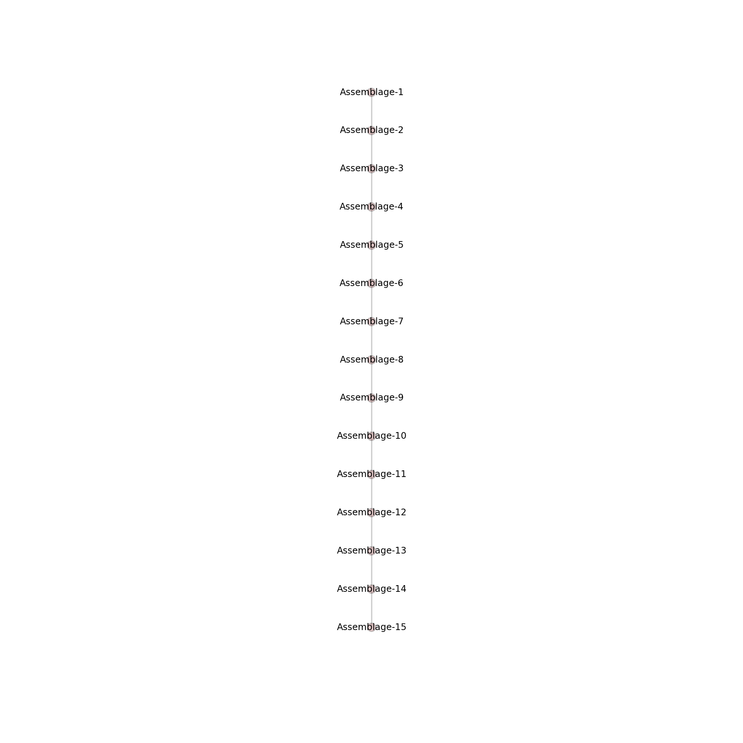

Figure 3. Graph representation of seriation solution.



Figure 4. Seriation results when more than one solution is possible within a set of assemblages. In this example, we begin with three valid seriation solutions (1-3) for the same set of 9 assemblages (A-I). Here, the thickness of the edges reflects the summed differences in frequencies between each pair of assemblages. The seriation solutions are then added together to create a summed solution consisting sum of edges from the individual graphs. From the sum of the solutions, we create a ‘minmax’ solution. This steps involves constructing a graph starting with the edges that have the smallest weight, as calculated by the sum of the differences in frequencies. Edges that include new vertices are added sequentially until all of the connected vertices are included. Edges that already connected through edges of lesser weight.

|  |  |  |  |  |  |  |
| --- | --- | --- | --- | --- | --- | --- |
| **Assemblage Name** | **Type_1** | **Type_2** | **Type_3** | **Type_4** | **Type_5** | **Type_6** |
| Assemblage-1 | 0 | 30 | 20 | 50 | 0 | 0 |
| Assemblage-2 | 10 | 20 | 20 | 50 | 0 | 0 |
| Assemblage-3 | 20 | 15 | 25 | 40 | 0 | 0 |
| Assemblage-4 | 30 | 10 | 30 | 30 | 0 | 0 |
| Assemblage-5 | 40 | 5 | 40 | 15 | 0 | 0 |
| Assemblage-A6 | 50 | 0 | 40 | 10 | 0 | 0 |
| Assemblage-A7 | 55 | 0 | 35 | 5 | 5 | 0 |
| Assemblage-A8 | 45 | 0 | 30 | 5 | 20 | 0 |
| Assemblage-A9 | 40 | 0 | 20 | 0 | 40 | 0 |
| Assemblage-A10 | 38 | 0 | 7 | 0 | 55 | 0 |
| Assemblage-B11 | 44 | 4 | 35 | 12 | 0 | 5 |
| Assemblage-B12 | 45 | 3 | 30 | 10 | 0 | 12 |
| Assemblage-B13 | 43 | 2 | 25 | 8 | 2 | 20 |
| Assemblage-B14 | 40 | 0 | 20 | 5 | 5 | 30 |
| Assemblage-B15 | 36 | 0 | 10 | 4 | 10 | 40 |



Figure 5. Frequency seriation of assemblages that comprise a branching lineage. The “A” and “B” series assemblages can all be seriated along with the first 5 assemblages but cannot be seriated as a single set without violations of the model.

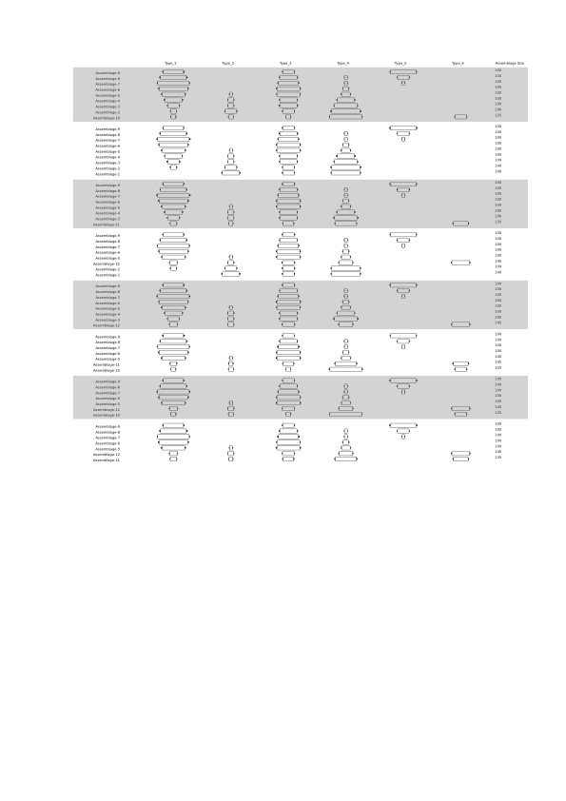

Figure 6. Set of all valid seriation solutions. Each of these orders is a valid deterministic frequency seriation solution.

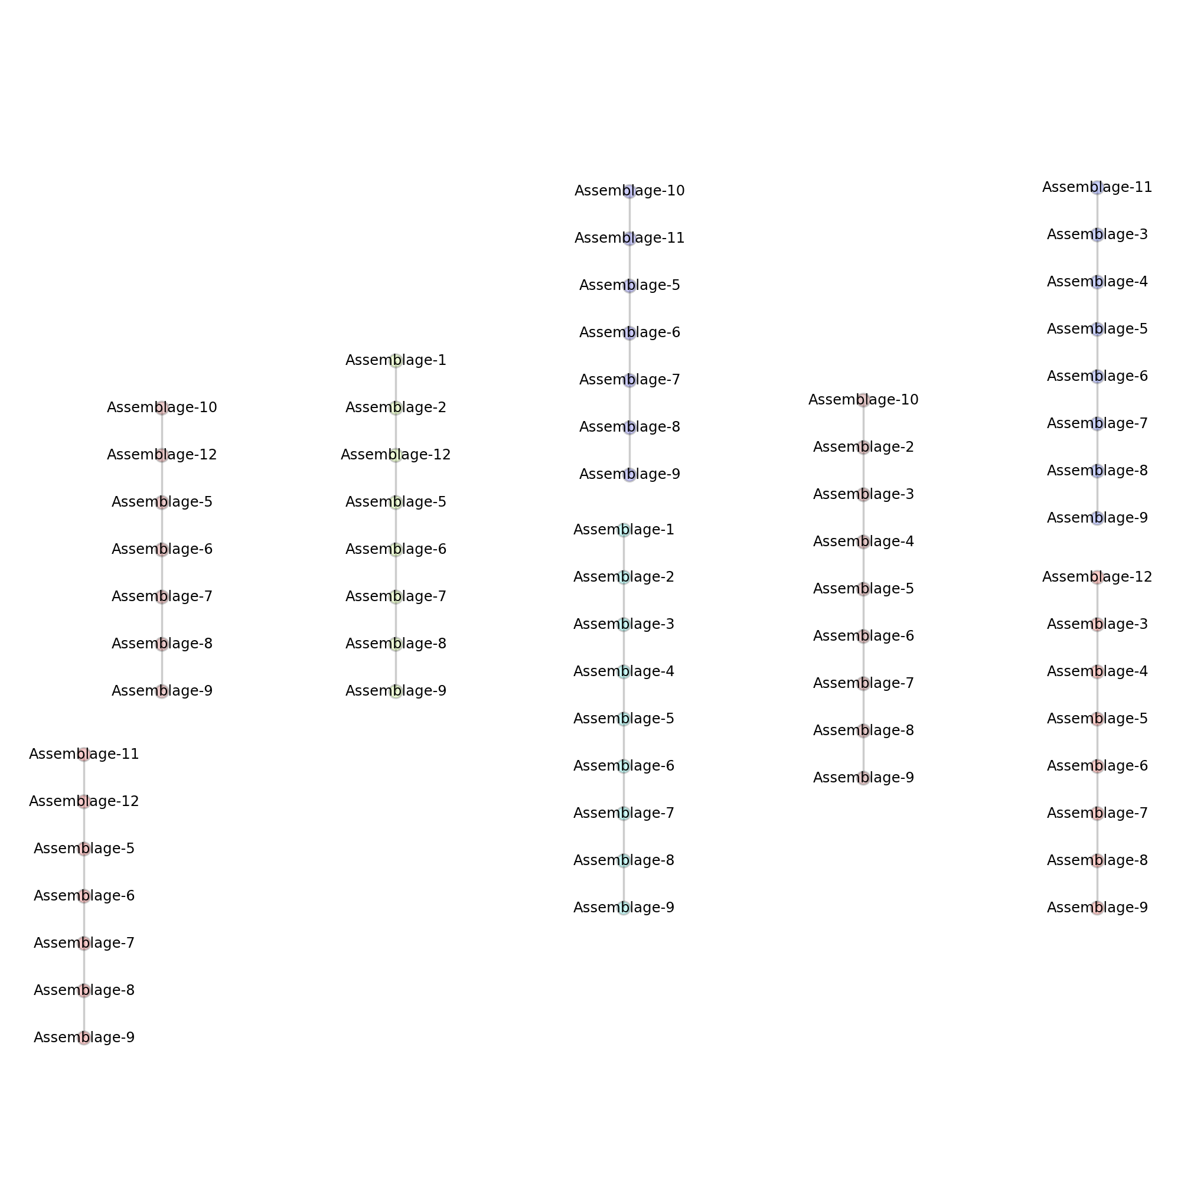

Figure 7. The set of all valid seriation solutions for the branching example represented in graph form. Note that none of the solutions contain all of the assemblages.



Figure 8. Sum of deterministic frequency seriation solutions in graph form. This figure consists of the sum of the edges and vertices in all of the valid seriation solutions in the graphs. The widths of the edges are proportional to the number of times the pair appears in the set of solutions.



Figure 9. The ‘minmax’ graph representation of the ‘branching’ example that includes seriation relationships for all assemblages added in the order of the smallest distances between pairs. The width of the edges is proportional to the summed frequency differences between the types in each pair of assemblages.

|  |  |  |  |  |  |
| --- | --- | --- | --- | --- | --- |
| **Assemblage Name** | **Type_1** | **Type_2** | **Type_3** | **Type_4** | **Type_5** |
| Assemblage-1 | 0 | 50 | 5 | 45 | 0 |
| Assemblage-2 | 0 | 48 | 5 | 47 | 0 |
| Assemblage-3 | 0 | 45 | 5 | 50 | 0 |
| Assemblage-4 | 0 | 30 | 20 | 50 | 0 |
| Assemblage-5 | 2 | 20 | 42 | 36 | 0 |
| Assemblage-6 | 0 | 19 | 56 | 3 | 22 |
| Assemblage-7 | 1 | 8 | 63 | 4 | 24 |



Figure 10. Example set of assemblages that cannot be seriated together due to a violation in the distribution of frequencies. Assemblage 6 lacks Type_1 material and thus is not continuous with Assemblage 5 and 7.

 

B

A

Figure 11. The ‘minmax’ graph solutions include for the assemblages in Figure 10. In Figure 11A, the seriations are created through direct comparison of the frequency values. In Figure 1B, the seriations are created through statistical comparisons using bootstrapped confidence intervals for the type frequencies (α=0.001). When confidence intervals are considered, there are a greater number of possible valid solutions. As a result, we can find the longest solution that meets our specified level of significance.

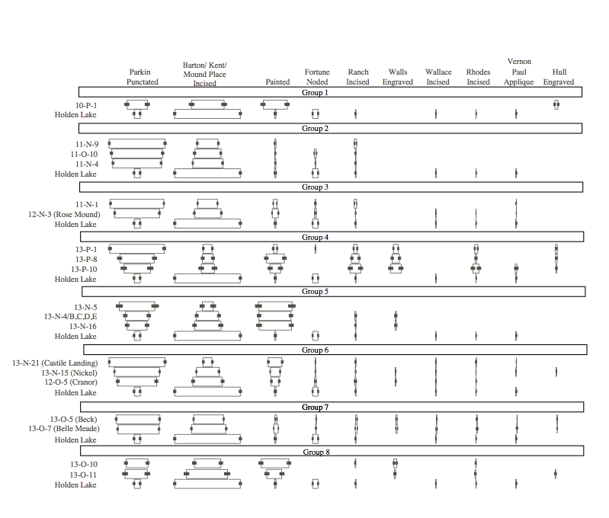

Figure 12. The set of deterministic frequency seriations created by hand sorting by Lipo (2001) in the Memphis and St. Francis areas of the Lower Mississippi River Valley Survey (Phillips et al. 1951). Here, the assemblages have been standardized in terms of type descriptions and are all of sufficient sample sizes. The error bars indicate the 99% confidence interval for the type frequencies. The largest seriation solutions formed eight spatial sets. Parkin (11-N-1) falls into two different sets, suggesting that it served as a central node of interaction between communities. Holden Lake appears as a valid addition to all of the seriation suggesting that it is earlier than the other assemblages in the analysis.



Figure 13. Spatial distribution of seriation groups with St. Francis and Memphis Assemblages consisting of Lipo (2001) and PFG (1951) samples. Labels for groups refer to seriation solution in Figure 12. As shown in the seriation solutions, each group should also include Holden Lake. The group boundaries do not include Holden Lake here for visual clarity.

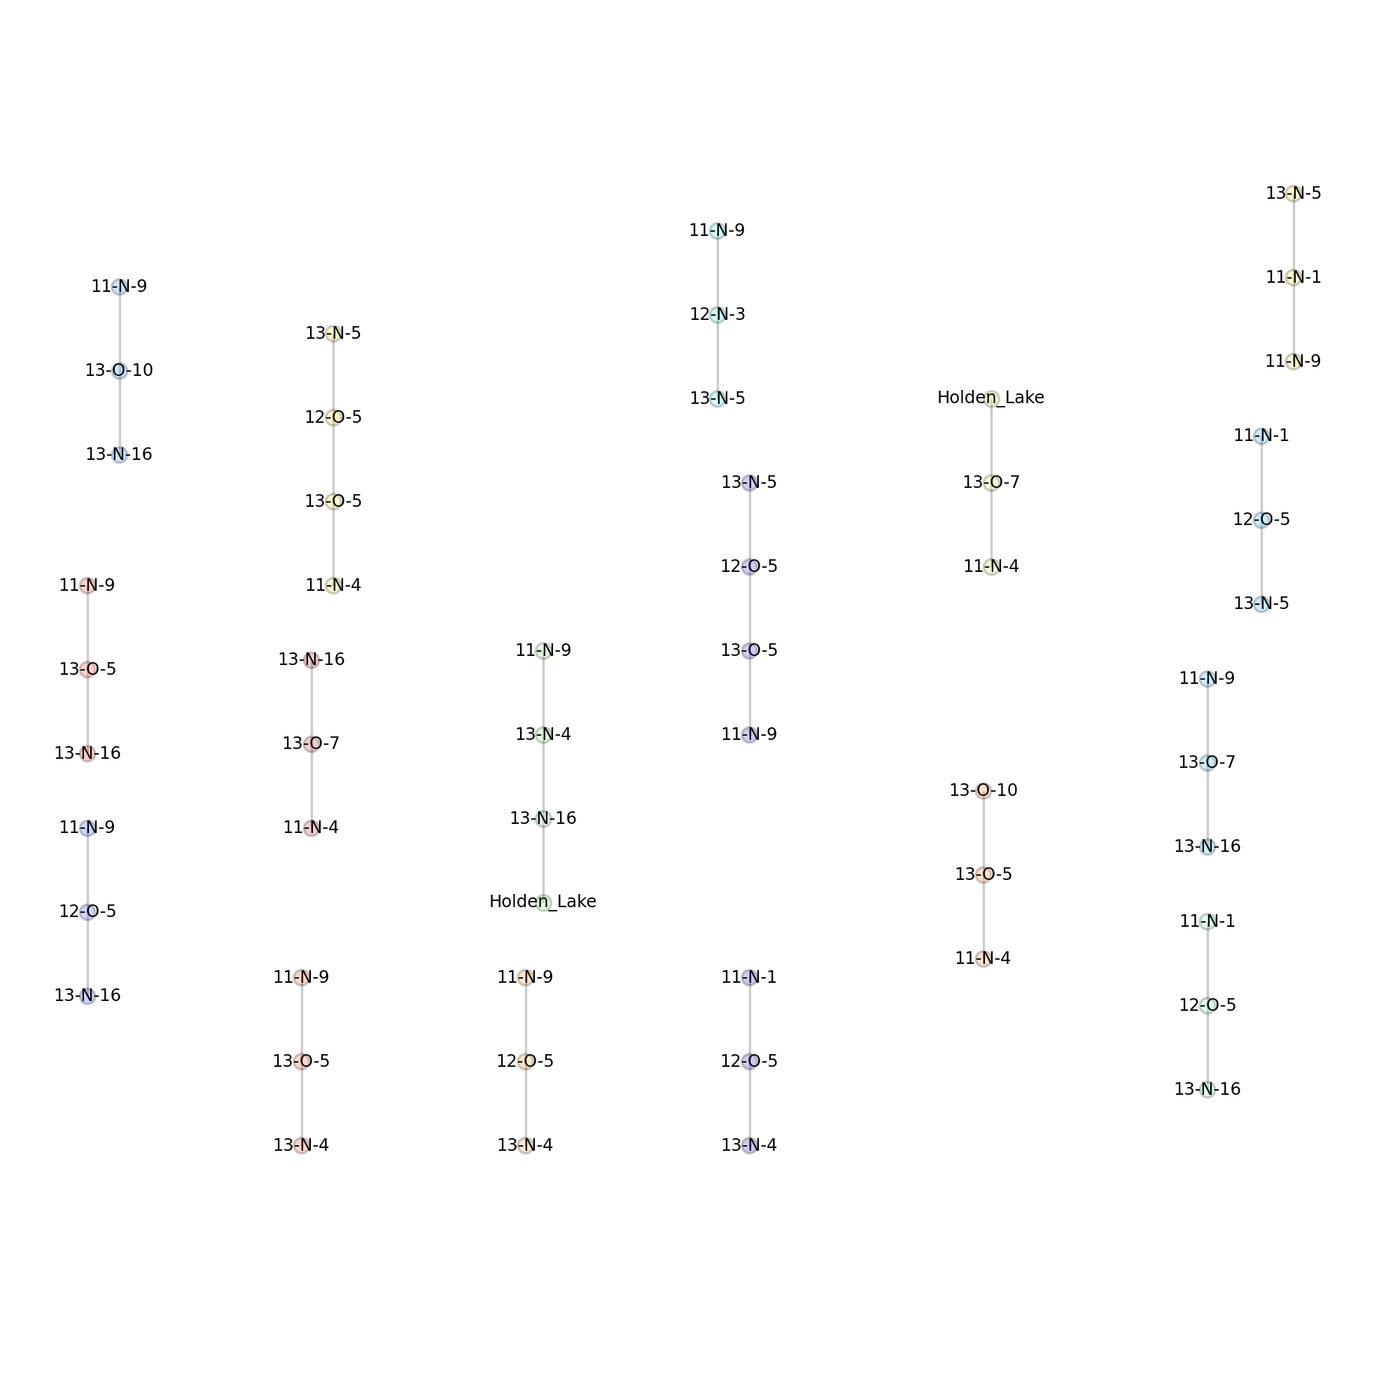

Figure 14. The largest set of valid frequency seriation solutions created using the IDSS algorithm for the St. Francis and Memphis area assemblages as described by Lipo (2001).



Figure 15. Graph representation of all seriation solutions for the St. Francis and Memphis assemblages summed together. The width of the edges reflects a measure of differences between assemblages calculated as the sum of the differences of frequencies between types. Not all of the assemblages can be added to the set of solutions as shown by the vertices without edges.



Figure 16. The ‘minmax’ spanning graph created from the sum of the deterministic frequency seriation solutions for the St. Francis and Memphis area assemblages.

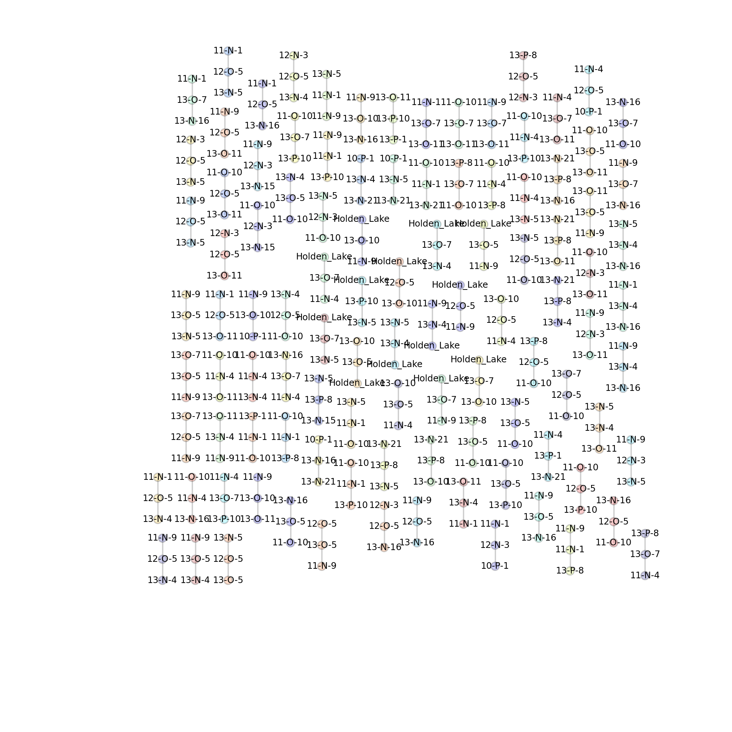

Figure 17. All of the valid deterministic frequency seriation solutions for the Memphis and St. Francis area assemblages using a 0.995% confidence intervals (α=0.005) for frequency comparisons. The confidence intervals for each assemblage are determined using 1000 bootstrap samples for each pair of assemblages.



Figure 18. Graph representation of the sum of all valid deterministic frequency seriations solutions generated the IDSS algorithm and using 0.995% confidence intervals (α=0.005) for the comparison of frequencies.



Figure 19. The ‘minmax’ graph for the valid deterministic frequency seriations solutions generated the IDSS algorithm and using 0.995% confidence intervals (α=0.005) for the comparison of frequencies. Note that Parkin (11-N-1) forms the center of a branch that extends in 3 different directions (to 11-N-9, 13-P-1 and 11-O-10). 13-O-7 and 13-O-10 also have this same configuration. 13-O-7 has an extra branch leading to Holden Lake, a presumably earlier deposit.



Figure 20. The spatial distribution of the edges formed in the minmax graph shown in Figure 19. Note that the edges have a strong spatial pattern in that vertices next to each other are more likely to be paired in seriation solutions than those that are farther away. A bootstrap assessment of the significance of this spatial pattern shows that *p*=0.04.



Figure 21. Spatial groups of assemblages.

1. Formally, seriation by similarity matrix analysis is known to belong to the class of problems called "NP-complete," which denote problems for which no known algorithm exists to enumerate possible solutions in a reasonable amount of time. NP-complete problems have computational requirements that scale exponentially or worse, and as the number of data points (or the size of the similarity matrix) grows, the number of solutions that must be tested can grow much faster than our ability to test their correctness. Seriation, in the form of similarity matrix analysis, has long suspected to be in the class of NP-complete problems. This suspicion was proven by George and Poten (1997).